7-2 Project Submission

Joel De Alba

Southern New Hampshire University

Professor Dr. Tad Kellog

06 / 18 / 23

Upon initial project analysis, the first step is to ensure the database of AAC and animals is imported correctly. This can be inspected by implementing the following:

cd /usr/local/datasets - Changing directory to the proper directory within the Aporto Virtual Lab

ls -la - Displays the directory files and content.

mongosh - Runs Mongo Shell to manage databases and collections.

cd /usr/local/datasets - Changing directory to the proper directory within the Aporto Virtual Lab

ls -la - Displays the directory files and content.

mongosh - Runs Mongo Shell to manage databases and collections.

Below is an example image of the process:

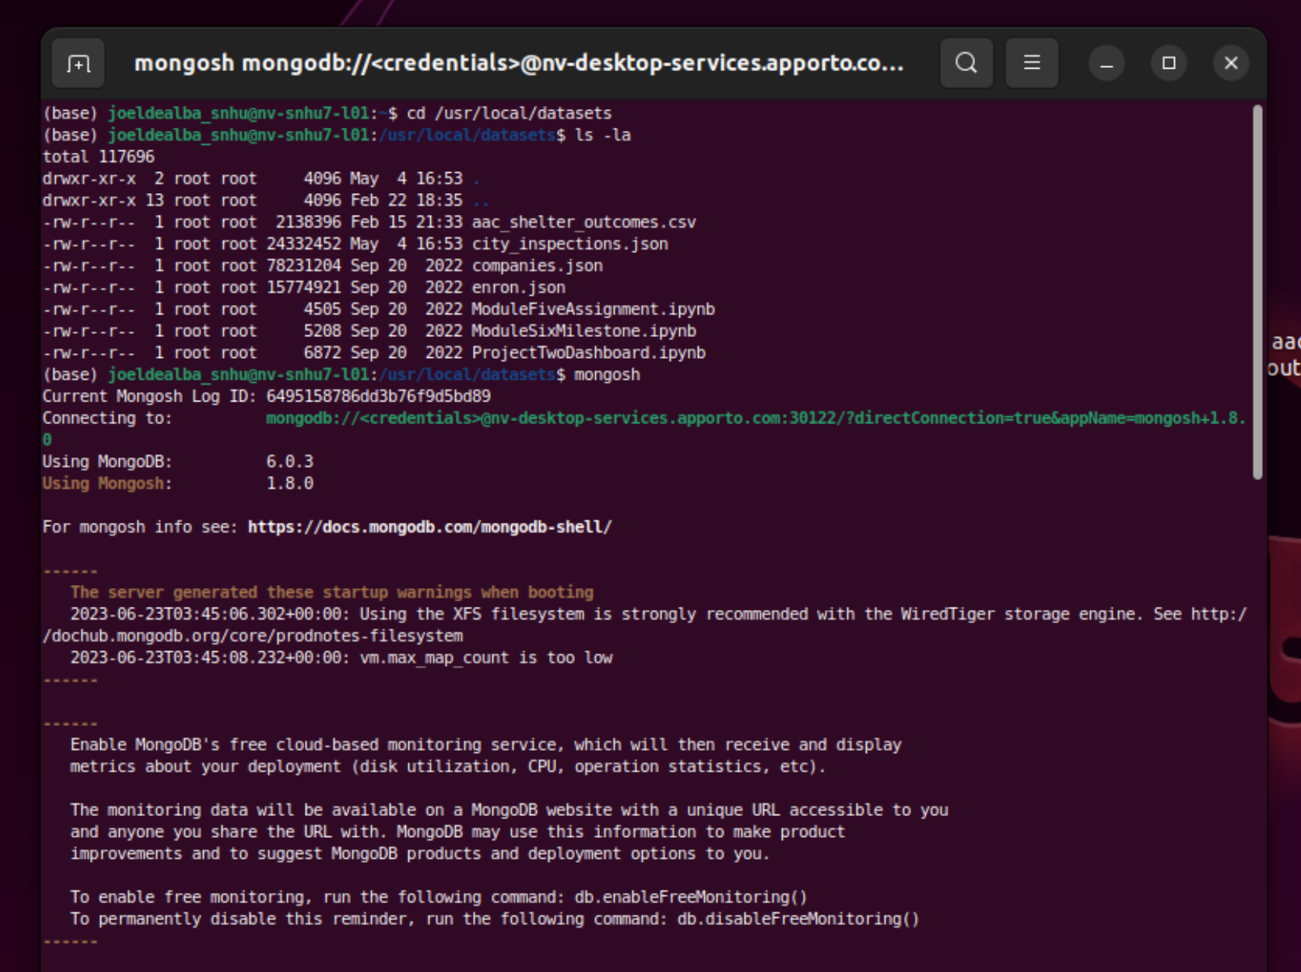

The following step from here would be ensuring that the collections are found within the database, from here we can also review if the user “aacuser” was created within the admin database, if not we need to create the user.

The needed admin user can be created as follows:

mongosh - Runs Mongo Shell to manage databases and collections.

show dbs - Provides visual display of databases found.

use admin - Instructing MongoDB that the admin DB will be utilized.

* The code below illustrates how to create new user to the admin db

db.createUser({user: “aacuser”, pwd: “SNHU1234”, roles: [{role: “userAdminAnyDatabase”, db: “admin”}]})

* The result should look as follows when successful:



Since the user was created in the previous modules and projects, the user already exists within the Virtual Lab MongoDB Admin Database. The following code illustrates how databases, collections, documents, and even users can be located withing the mongo shell:

mongosh - Runs Mongo Shell to manage databases and collections.

show dbs - Provides visual display of databases found.

use admin - Instructing MongoDB that the admin DB will be utilized.

show collections - Displays existing database collections

db.collection.find() - Finds and Displays all documents found within the collection of the used database

The following image shows this code being implemented:

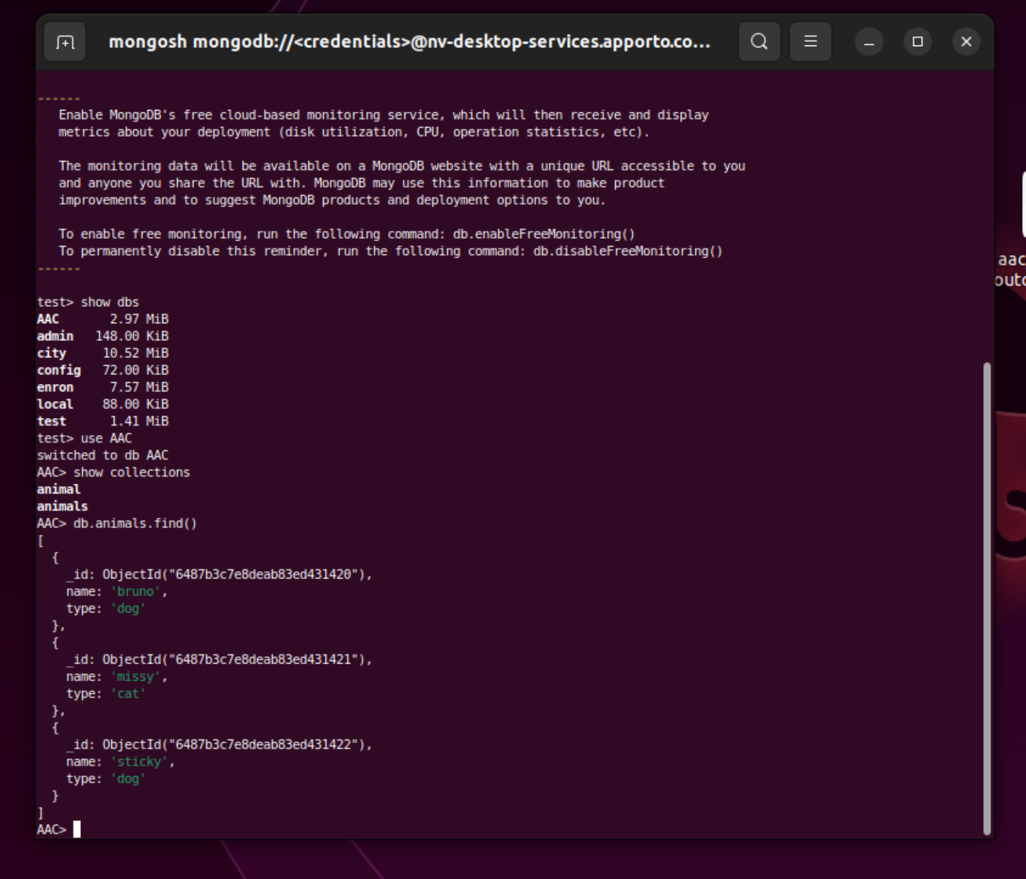

The following code depicts the process for user retrieval from admin database and system.users collection. This can be done be either of the following code shell examples:

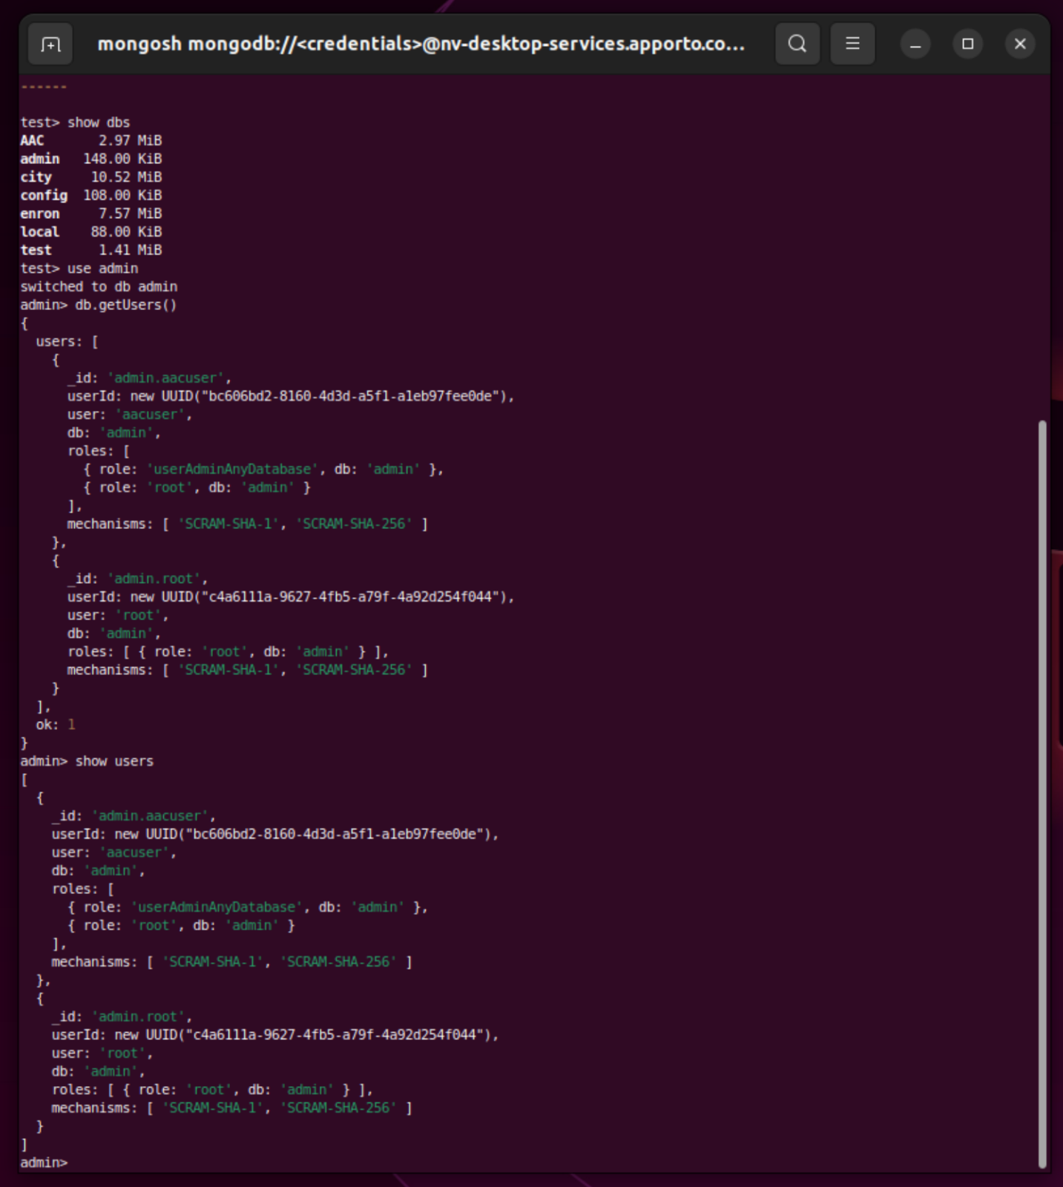

mongosh - Runs Mongo Shell to manage databases and collections.

show dbs - Provides visual display of databases found.

use admin - Instructing MongoDB that the admin DB will be utilized.

show users - Displays users found in the admin database.

db.getUsers() - Another method used to display users found.

The following image shows the code above being implemented with db.getUsers():



mongosh - Runs Mongo Shell to manage databases and collections.

show dbs - Provides visual display of databases found.

use admin - Instructing MongoDB that the admin DB will be utilized.

show users - Displays users found in the admin database.

db.getUsers() - Another method used to display users found.

The following image shows the code “show users” being implemented:

Once we have reviewed that the databases and users are set accordingly, next we begin by setting the database connection details, uploading the documents, logo image, and all project prerequisites. This process can be seen in the following image:

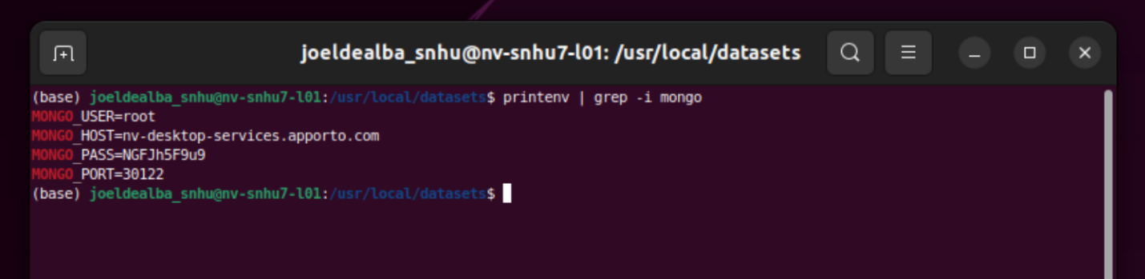First, we must review and edit the mongo environment variables and ensure they correlate with our project in development, doing this ensures the database information can be located. The following command prints the variables that are currently set, these can be edited similarly to how they are displayed:

The following image displays how the environment variables can be updated:

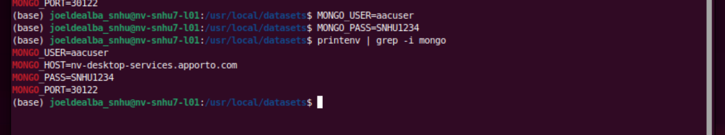

From this point, we can finally begin implementing the Dashboard in Jupyter Notebook, we begin by ensuring the environment variables correlate to ensure the application can detect and collect MongoDB databases.

We can run Jupyter Notebook either by locating the application icon or running the shell command “jupyter notebook” as follows:



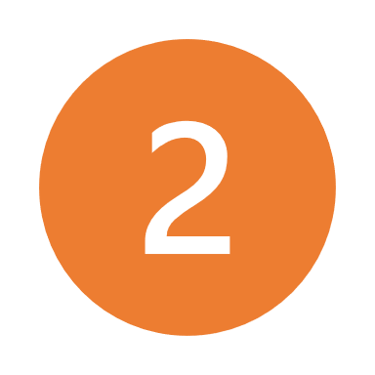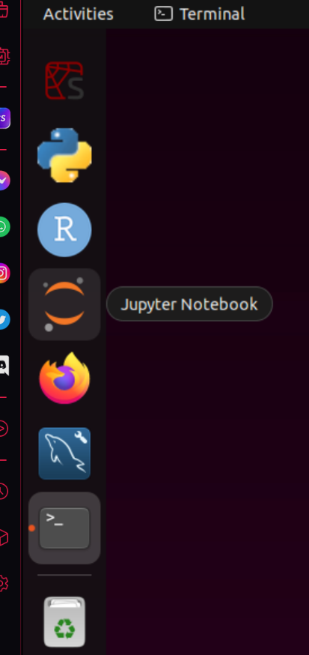

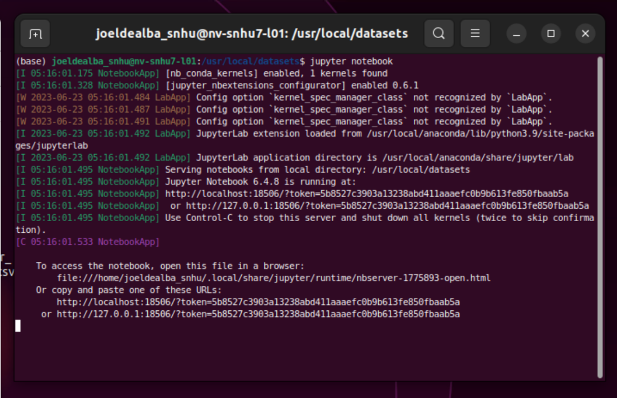

Once the execution command is run successfully, the following image represents how the Jupyter Notebook should look within the browser, keep in mind the directories may have to be maneuvered to find the project files:

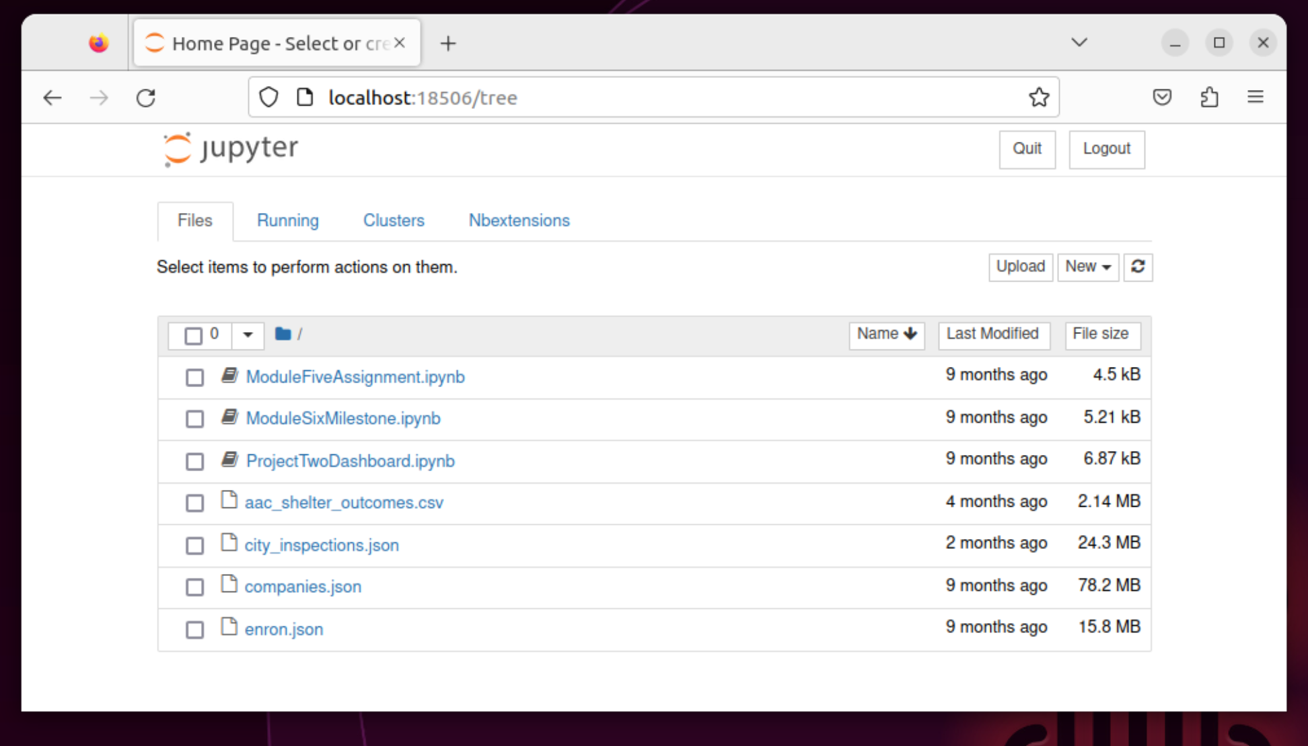

Here we can see that python was initialized, the primary file we need to update and modify is ProjectTwoDashboard.ipynb:



Let’s examine our requirements. We must first ensure we have the proper dependencies, as such we need use the pip command for Dash Core Components to be installed so our Dashboard interface is displayed correctly with HTM. We do this by implementing the following command:

pip install jupyter-dash

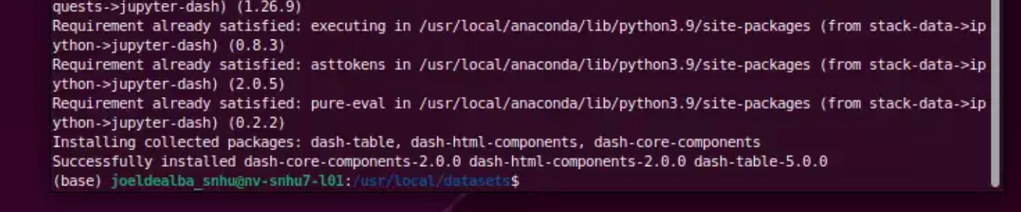

Any other required dependencies are numpy and panda:

pip install pandas

pip install numpy

Also don’t forget to include all the Dash Dependencies:

pip install dash

pip install dash==2.0.0

pip install dash-leaflet==0.1.23

pip install dash-extensions==0.0.65

The following images will provide an example of what the scripts and python CRUD file looks like:

1. Initial Imports

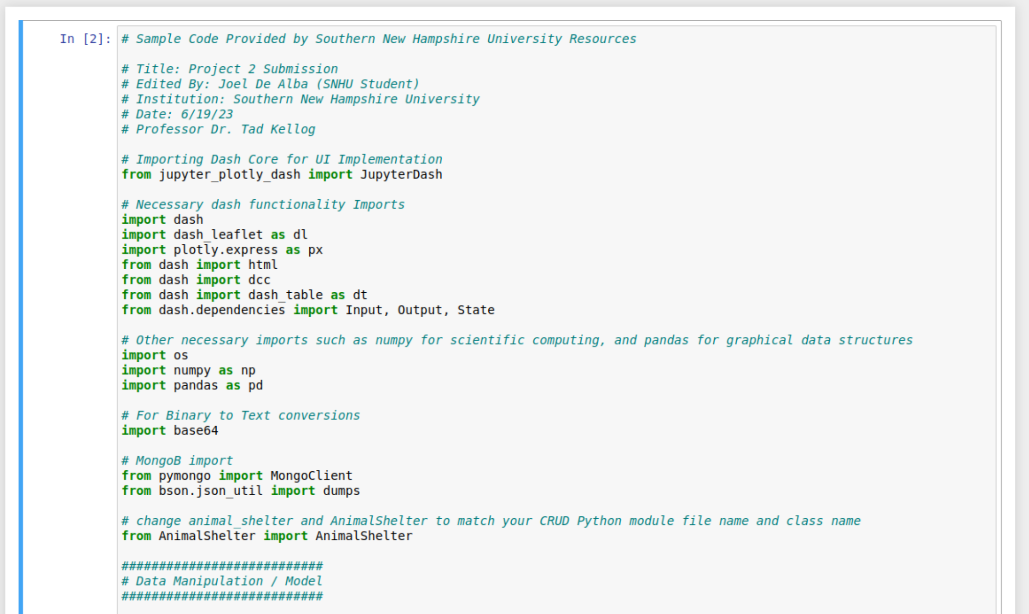

1. Image and Personal Identifiers

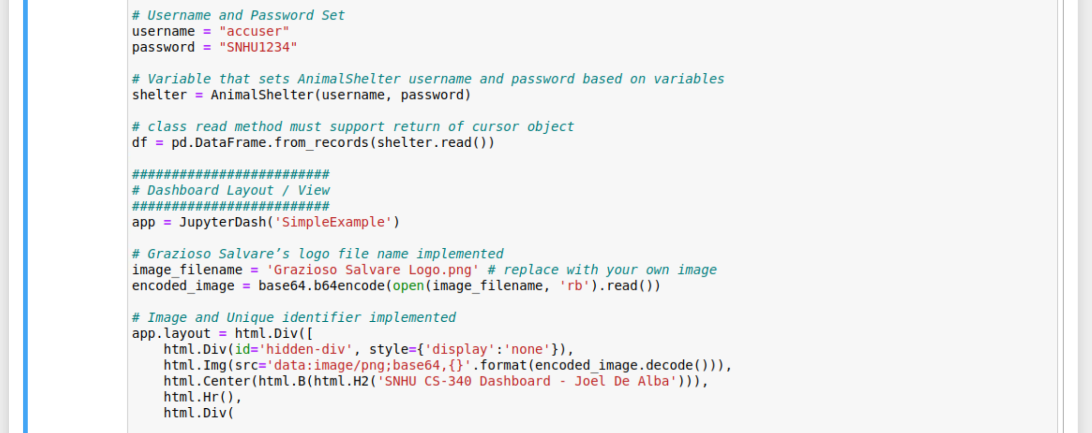

1. Action Buttons for Sorting Options

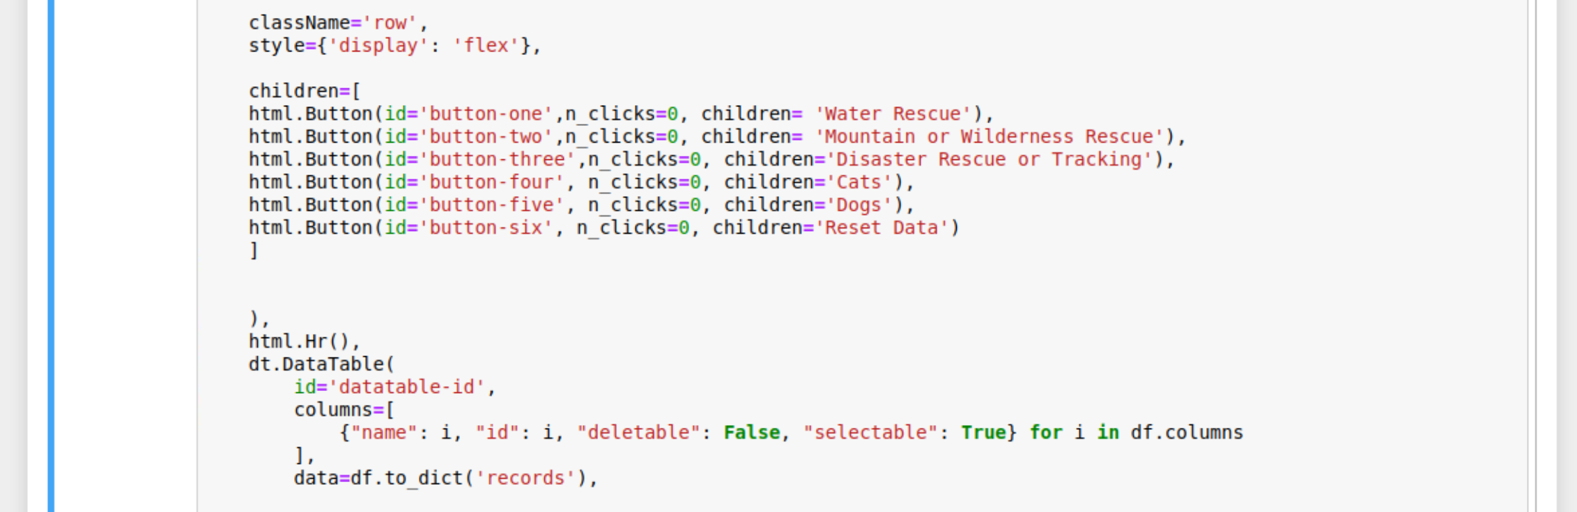

1. Data table Structure

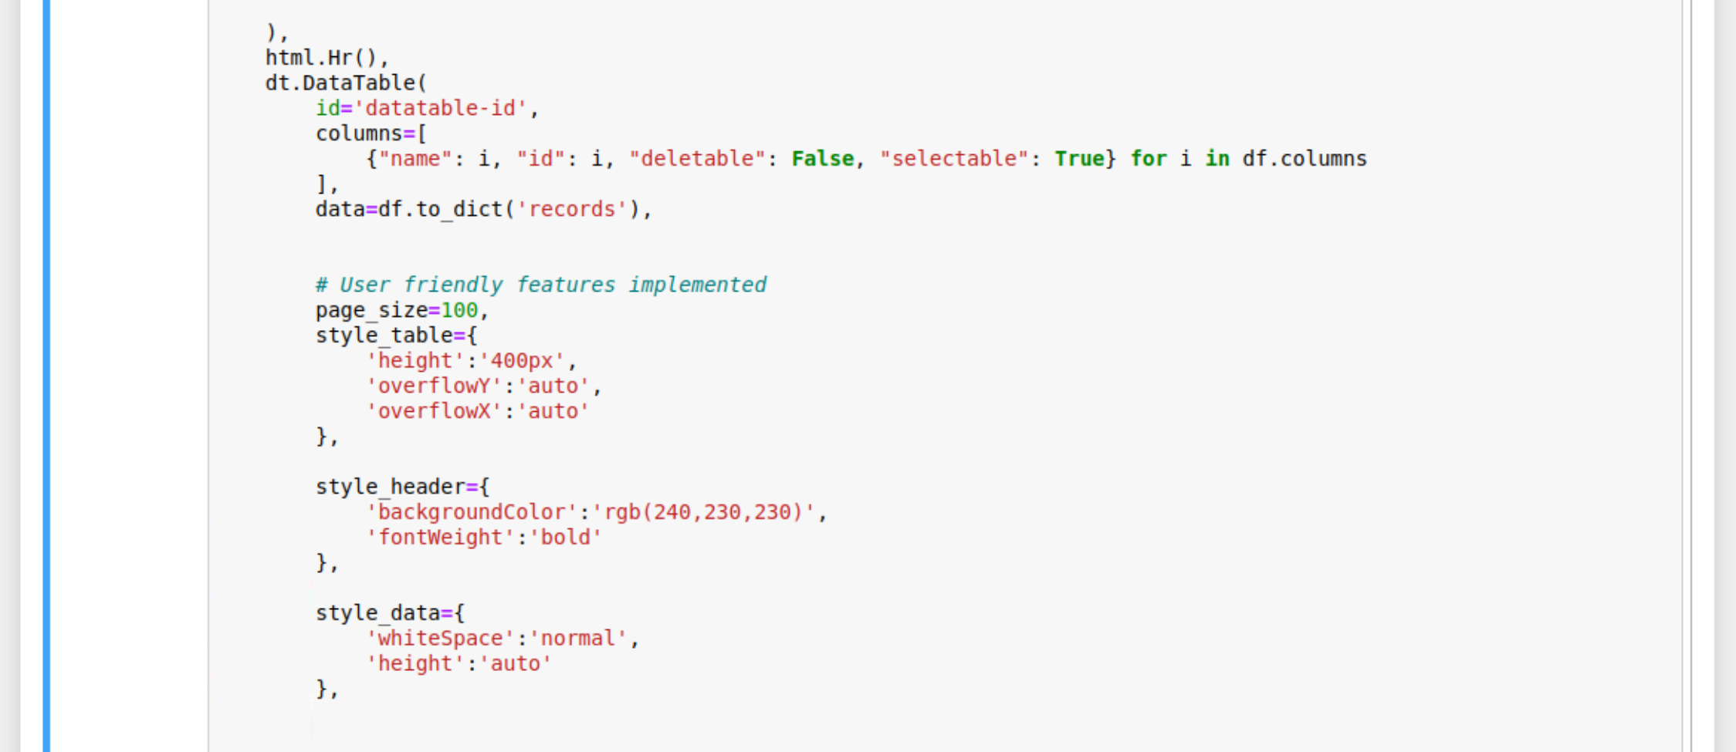

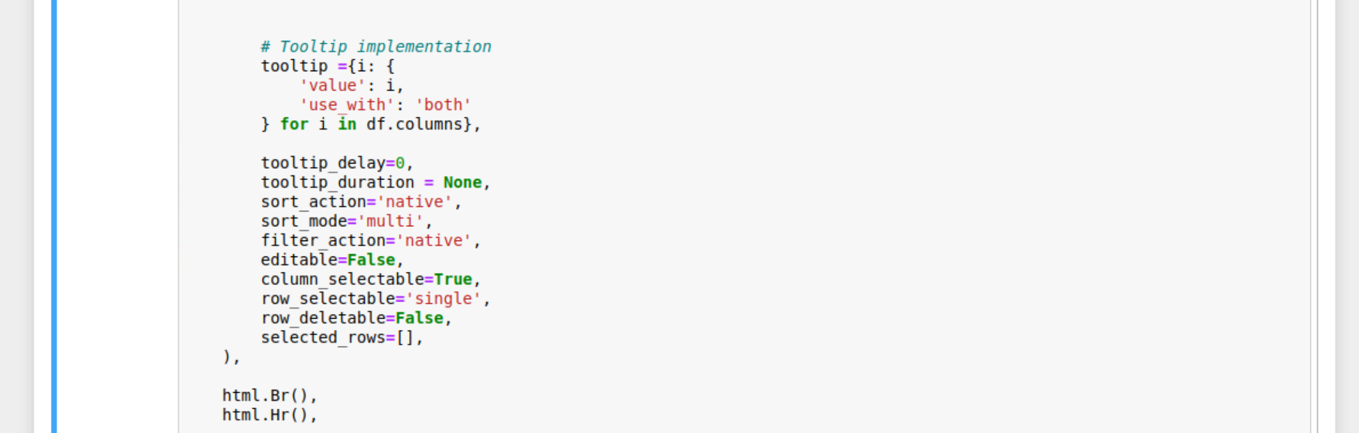

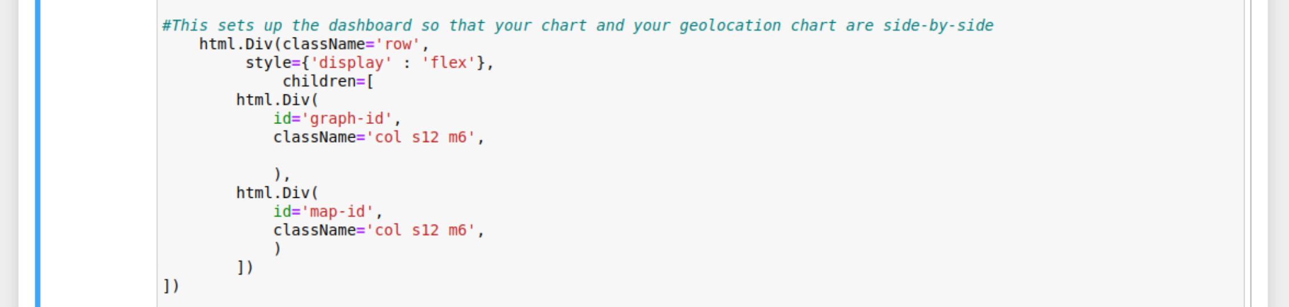

1. Button Interactions / Dashboard Updates

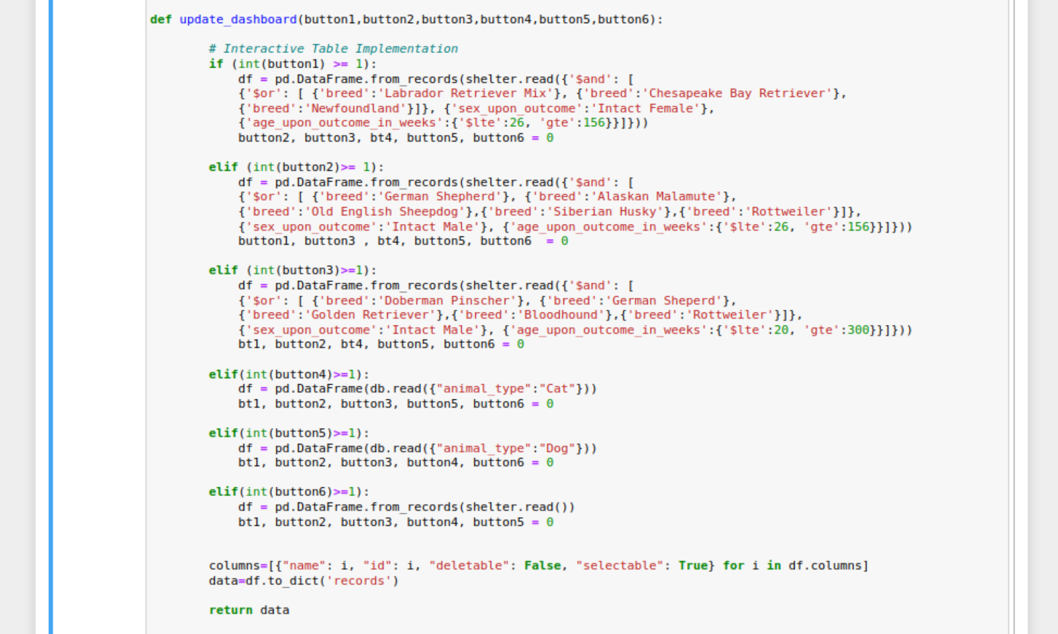

1. Callbacks

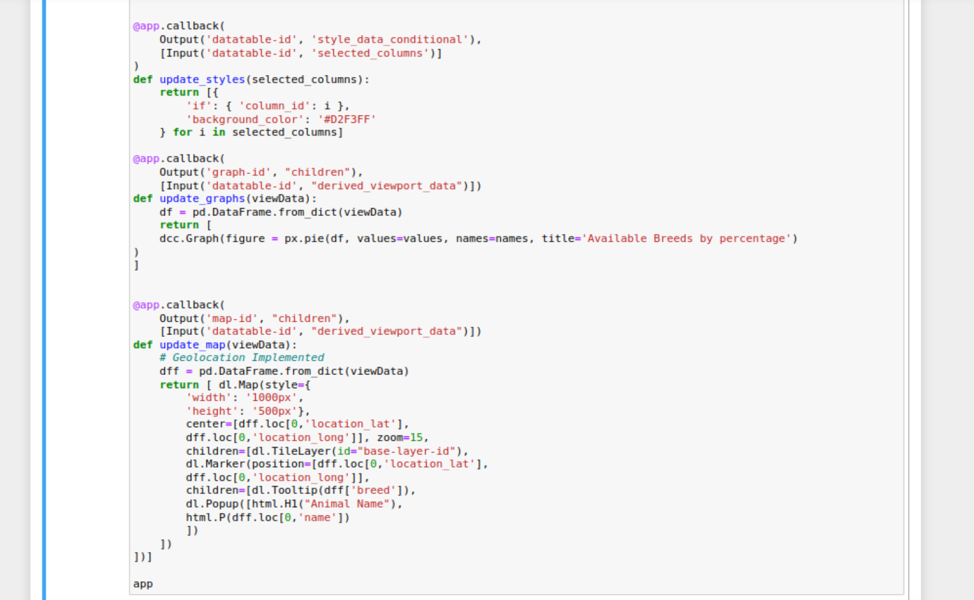

1. Python CRUD Implementation – Create and Read

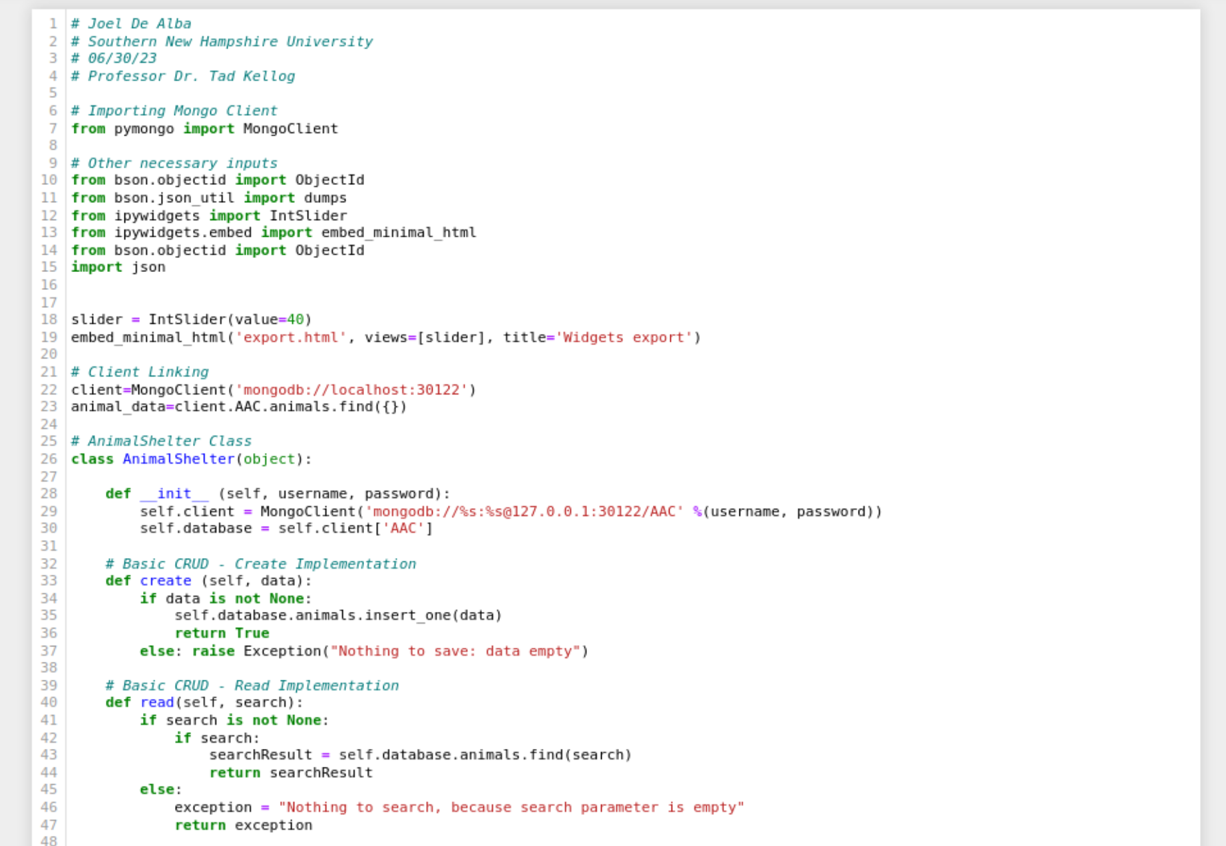

1. Python CRUD Implementation – Update and Delete

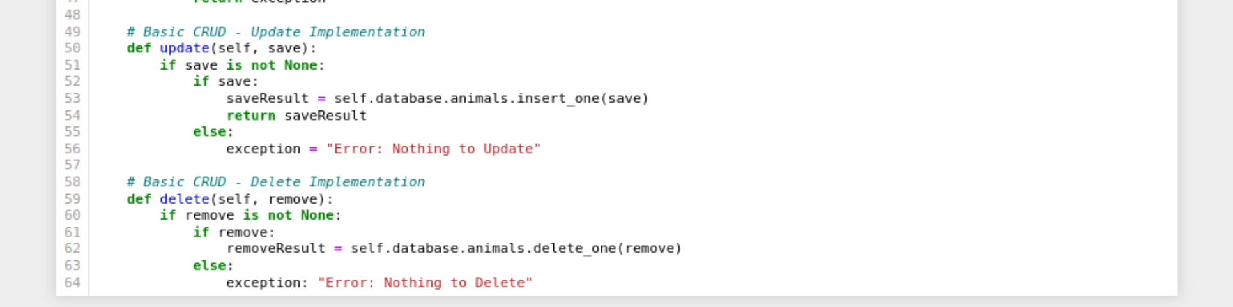

Gathered from the project work, this compilation of files generate a table that is pulled from the AAC database with the CRUD python file implementation.

**Sources**

*Dash Core Components | Dash for Python Documentation | Plotly*. (n.d.). https://dash.plotly.com/dash-core-components

*Dash DataTable | Dash for Python Documentation | Plotly*. (n.d.). https://dash.plotly.com/datatable

*Dash*. (n.d.). https://dash-leaflet-docs.onrender.com/

*Sorting, Filtering, Selecting, and Paging Natively | Dash for Python Documentation | Plotly*. (n.d.). https://dash.plotly.com/datatable/interactivity

*Pie*. (n.d.). h Alex Giamas. (2022).

Mastering MongoDB 6.x : Expert Techniques to Run High-volume and Fault-tolerant Database Solutions Using MongoDB 6.x: Vol. Third edition. Packt Publishing.ttps://plotly.com/python/pie-charts/